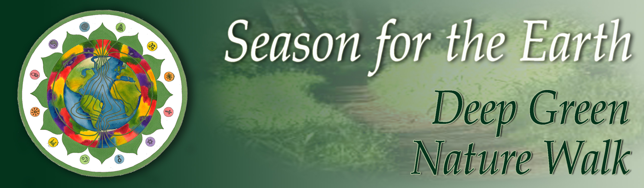

**Sacred Nature Walk in the “Spirit of Thoreau”.**

Date:

Time:

Location/ Meetin Place:

I think that I cannot preserve my health and spirits, unless I spend four hours a day at least - and it is commonly more than that - sauntering through the woods and over the hills and fields, absolutely free from all worldly engagements.   
~Henry David Thoreau

I only went out for a walk and finally concluded to stay out till sundown, for going out, I found, was really going in.   
~John Muir

This Season for the Earth we invite you to take a journey back to the roots of New Thought and Deep Ecology.

**DEEP GREEN** is about getting back to our spiritual roots, some of which are planted in America’s profound history of New England transcendentalism.  
  
This program invites you to re-immerse yourself, in a study group or on your own, in the wisdom of our fore-bearers whose depth of thought and feeling in relationship with the natural world may offer a fresh perspective for the challenges we face today.

Contemplate, meditate, be drawn into deep conversation about the Earth. Spend time in nature. **Walk** and bring those thoughts home with you. Share them here, through online journaling, with your extended network of friends in Season for the Earth around the globe.

